- While assigning a doctor to any OPD – only the doctors available for the date selected (same in case of recurring dates as well) to be shown – and the doctor’s OPD timing for that particular date should be auto-filled. The below screenshot shows wrong auto-fill of that doctor. The system should not auto-fill time slots from emergency but only from OPD schedule of that doctor.
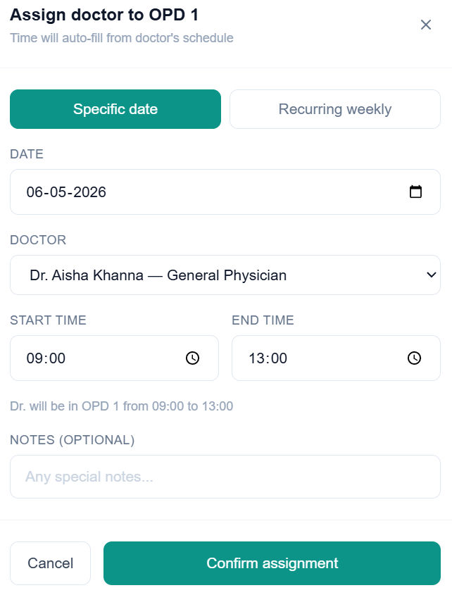
- Receptionist (reception screen) is not showing OPD sessions although a doctor has been assigned at this time to OPD 1
